Simple API Example

## Part 1

Create a web API web application in VS 2015

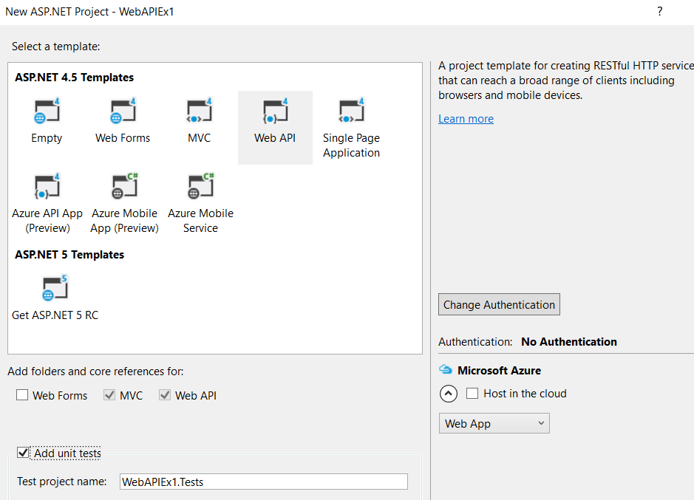

Build and Run the App

Install Postman in Google Chrome

Test against the Values API controller.

The default control HTTP verbs are GET, GET with an argument, POST and PUT

The values controller will expect to see the following signature for values default get all

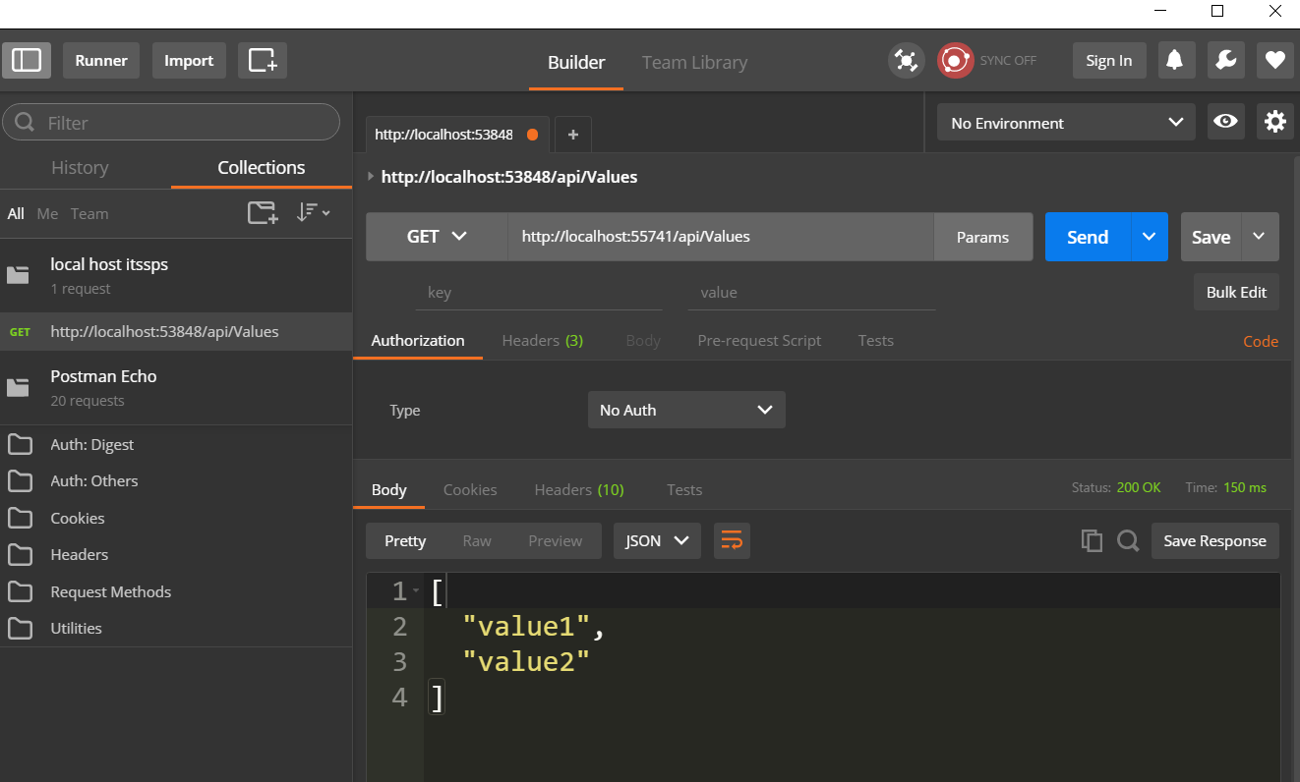

Default for single get

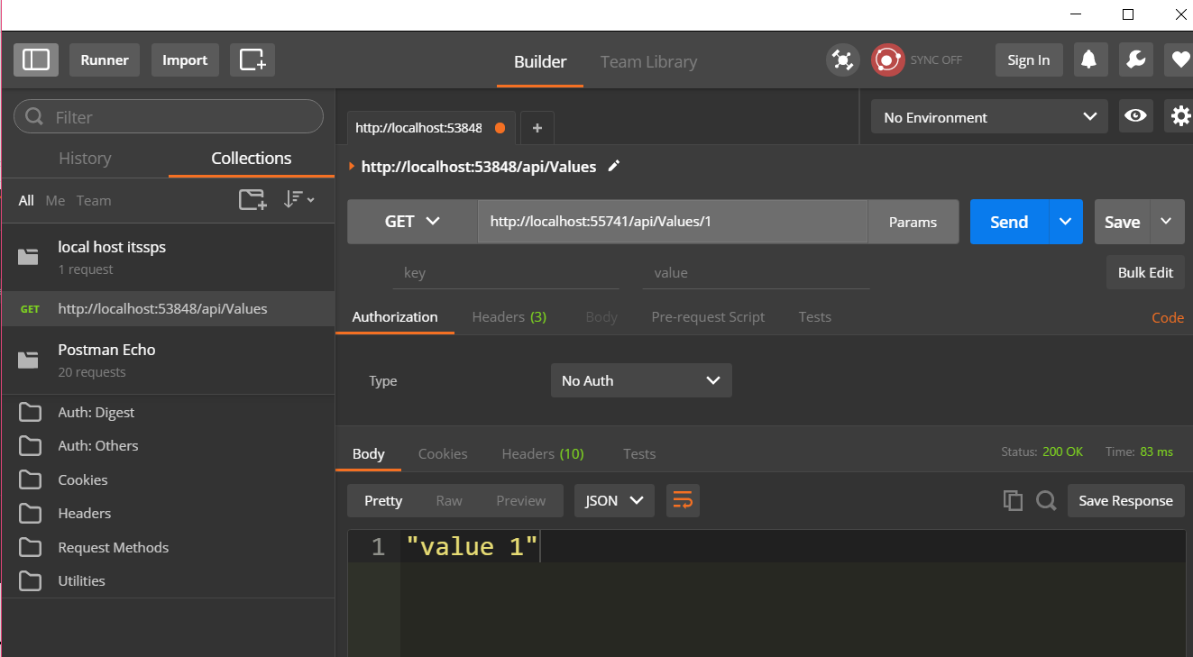

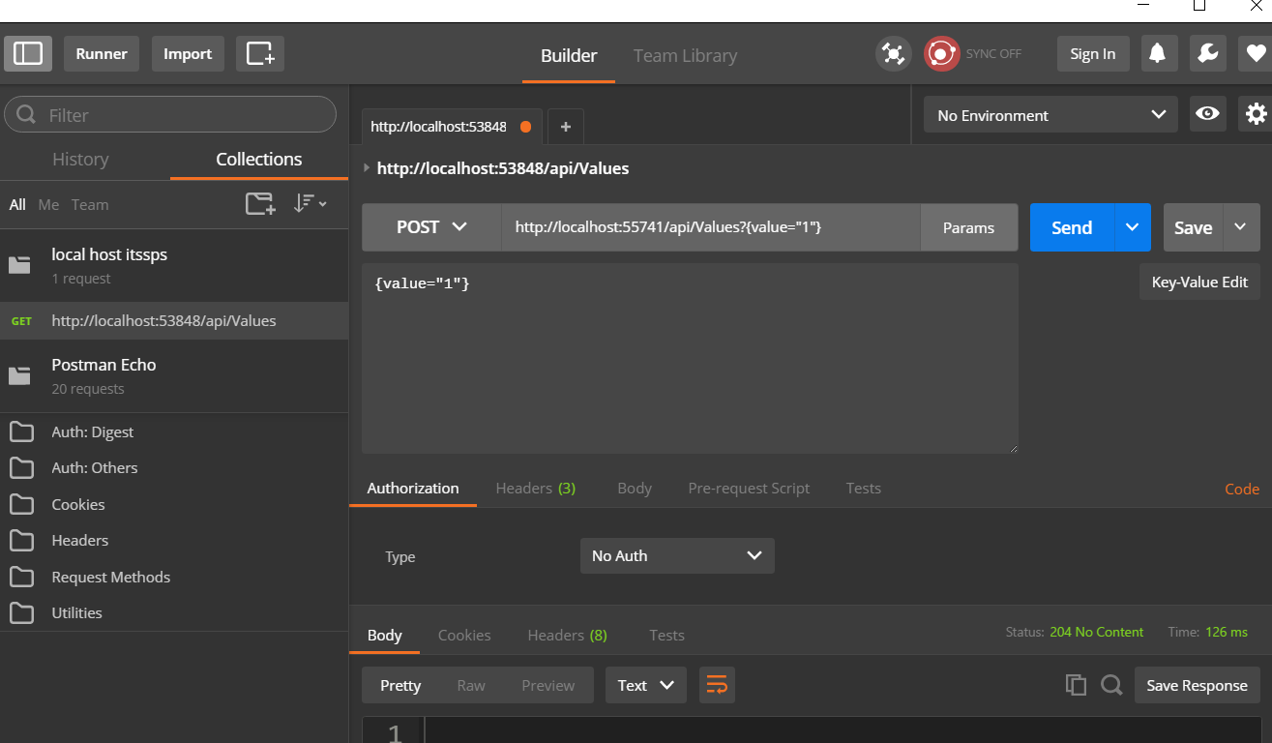The Default Post call would be

Note the associated method is void as a return hence the 204 No Content

Change the route signatures on the value Web API controller to the following

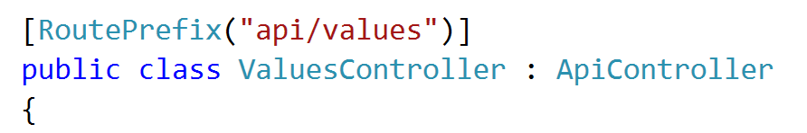

Controller Action signatures

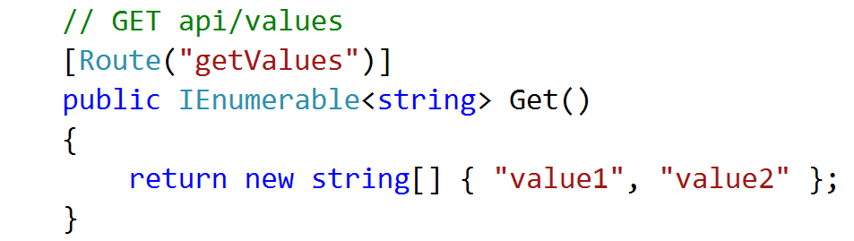

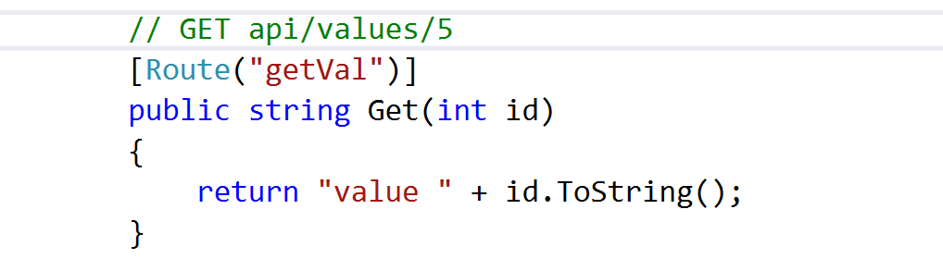

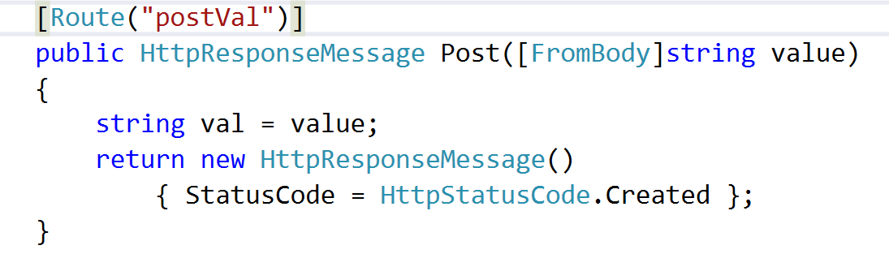

Design appropriate Web API Calls in Postman to call these actions

# Part 2

Create and seed the following model using the student seeding from

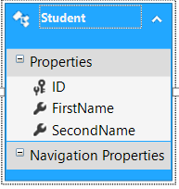

Create a web API controller based on this model

Customize the Route attributes on the Controller and Actions and test in Postman